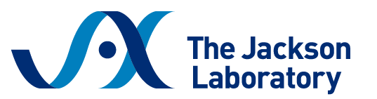
Sample Justification Letter
Workshop on Vascular Catheterization in the Laboratory Mouse
November 3 – 5, 2026 | Bar Harbor, Maine

Dear [Supervisor/PI Name],
I am writing to request approval to attend the Workshop on Vascular Catheterization in the Laboratory Mouse hosted by The Jackson Laboratory from November 3 – 5 in Bar Harbor, Maine.
This hands-on workshop is designed for researchers who use murine models in studies requiring vascular access and will provide advanced surgical training that directly supports our lab’s research goals, including:
- Jugular vein and carotid artery catheterization using vascular access buttons
- Dual catheterization techniques
- Aseptic surgical preparation and technique
- Anesthesia, analgesia, and post-operative care
- Suturing and wound closure methods
The in-person format emphasizes hands-on practice and expert instruction to ensure proper catheter placement and long-term patency—skills that are essential for reliable data collection.
The workshop registration fee is $2,150 and includes on-site lodging, all training materials, and most meals. Scholarships are available to partially cover the registration fee, and I plan to apply for one with your support.
Attending this workshop will allow me to improve the quality and reproducibility of our in vivo experiments, reduce procedural variability, and train other lab members in advanced surgical techniques.
Thank you for considering this request.

