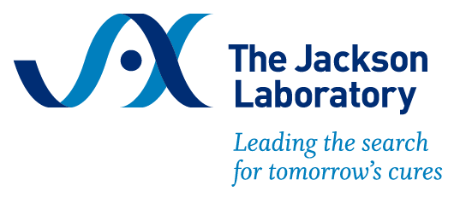
Sample Justification Letter
Workshop on Vascular Catheterization in the Laboratory Mouse
October 6 – 8, 2025 | Bar Harbor, Maine

Dear [Manager's Name],
I am writing to request approval to attend the Workshop on Vascular Catheterization in the Laboratory Mouse hosted by The Jackson Laboratory from October 6–8, 2025, in Bar Harbor, ME. This hands-on workshop is designed for researchers who use murine models in studies requiring vascular access and will provide advanced surgical training that directly supports our lab’s research goals.
The workshop covers:
- Jugular vein and carotid artery catheterization using vascular access buttons
- Dual catheterization techniques
- Aseptic surgical preparation and technique
- Anesthesia, analgesia, and post-operative care
- Suturing and wound closure methods
The in-person format emphasizes hands-on practice and expert instruction to ensure proper catheter placement and long-term patency—skills that are essential for reliable data collection.
The registration fee for the workshop is $1,750, which includes all training materials and most meals. Optional on-campus lodging is available for $300. Additionally, scholarships are available, which can partially cover the registration fee. I plan to apply for this scholarship by submitting a brief statement of financial need and a description of how the course supports my professional development.
Attending this workshop will allow me to improve the quality and reproducibility of our in vivo experiments, reduce procedural variability, and train other lab members in advanced surgical techniques. These improvements will directly benefit our research outcomes and align with our commitment to scientific rigor and animal welfare.
Thank you for considering this request.

