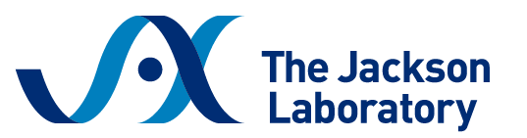
Sample Justification Letter
Workshop on Making and Genetically Manipulating Mouse Embryos
March 9 – 12, 2026 | Bar Harbor, Maine

Dear [Supervisor/PI Name],
I am writing to request your approval to attend the Making and Genetically Manipulating Mouse Embryos workshop hosted by The Jackson Laboratory in Bar Harbor, Maine, from March 9 – 12.
The workshop curriculum directly supports our research goals by strengthening the skills essential to developing innovative mouse models through embryo manipulation.
This in-person training covers:
- Mouse reproductive biology and embryo collection
- Cryopreservation and recovery techniques
- Pronuclear and cytoplasmic microinjection
- CRISPR/Cas9-mediated genome editing in embryos
- Embryo culture and assessment
- Surgical and non-surgical embryo transfer techniques
- Troubleshooting common challenges in embryo manipulation workflows
Participants receive intensive hands-on training from experienced JAX surgical and scientific staff, with individualized guidance throughout each procedure.
The registration fee is $3,000 and includes on-site lodging, all training materials, and most meals. Scholarships are available to partially cover the registration fee, and I plan to apply for one with your support.
Attending this workshop will enhance my ability to contribute to our team’s ongoing and future work by deepening my expertise in advanced embryo manipulation techniques, improving complex model generation workflows, and supporting more reliable research outcomes.
Thank you for considering my request.

