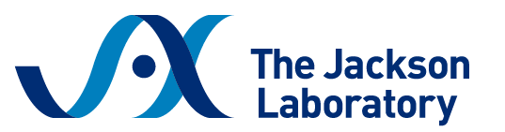
Sample Justification Letter
Workshop on Surgical Techniques in the Laboratory Mouse
April 14 – 17, 2026 | Bar Harbor, Maine

Dear [Supervisor/PI Name],
I am writing to request your approval to attend the Surgical Techniques in the Laboratory Mouse workshop hosted by The Jackson Laboratory in Bar Harbor, Maine, from April 14 – 17.
This in-person workshop is designed for researchers and veterinarians who perform or oversee surgical procedures in mice and offers a comprehensive curriculum that directly supports our research and animal care goals.
The workshop covers:
- Basic mouse anatomy
- Surgical space preparation and aseptic technique
- Anesthesia monitoring and post-operative care
- Microsurgical and injection techniques
- Castration, vasectomy, ovariectomy, ovarian transplantation
- Adrenalectomy, splenectomy, thymectomy, nephrectomy
- Jugular vein catheterization
Participants receive hands-on training from experienced JAX surgical staff with personalized feedback throughout. The workshop emphasizes both technical proficiency and foundational knowledge to improve surgical outcomes and animal welfare.
The registration fee is $2,800 and includes on-site lodging, all training materials, and most meals. Scholarships are available to partially cover the registration fee, and I plan to apply for one with your support.
Attending this workshop will allow me to refine my surgical skills, improve procedural consistency and animal outcomes, and share updated techniques with our team.
Thank you for considering my request.

